
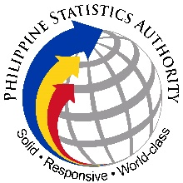
Republic of the Philippines
Philippine Statistics Authority
Capiz Provincial Statistical Office

SPECIAL RELEASE
Inflation Rate in Capiz continued to accelerate at 4.4
percent in May 2024

Date of Release: 08 June 2024
FFJ
Reference No. 2024 –
CONSUMER PRICE INDEX (2018 = 100)

Figure 1
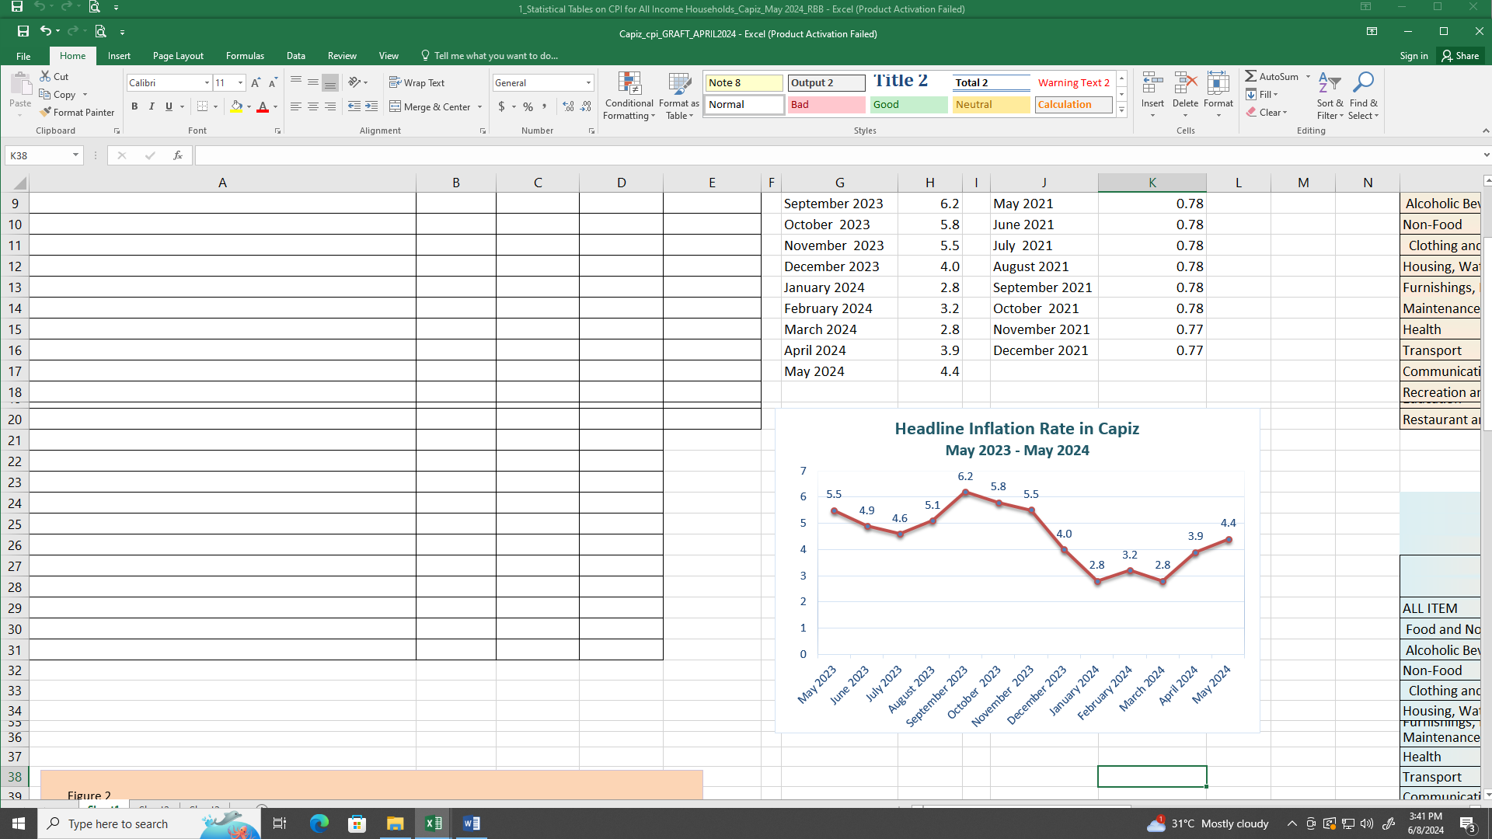
Source: Retail Price Survey of Commodities for the Generation of Consumer Price Index, Philippine Statistics Authority

The headline inflation in the province of Capiz continued to pick up to 4.4 percent in May 2024 from 3.9 percent in April 2024. This is the highest recorded inflation so far for the year 2024, but still the sixth lowest in the last twenty four months since the base year was changed to 2018. Inflation in May 2023 was higher at 5.5 percent. The average inflation for the year stood at 3.4 percent. (Figure 1 and Table A)
The provincial inflation continued to surge in May 2024, primarily due to a visible annual increase in the index of the most heavily weighted commodity group, Cereals and Cereal Products, at 15.3 percent, compared to 12.2 percent in April 2024. This increase was led by the most heavily weighted item in the provincial CPI, which is Rice, at 19.9 percent, up from 15.7 percent in the previous month.
In general, the Non-Food Commodity group also increased to 2.1 percent from 1.9 percent in the previous period. This increase was driven by Clothing and Footwear at 2.4 percent, up from 2.1 percent in April 2024, Transport at 0.5 percent, up from -0.3 percent, and Personal Care and Miscellaneous Goods and Services at 1.9 percent, up from 1.7 percent in the previous month (Table 4).
On the other hand, only two commodities belonging to the Non-Food group exhibited a drop in the annual inflation rate, namely Housing, Water, Electricity, Gas, and other fuels at 3.5 percent, down from 3.6 percent in April 2024, along with Recreation, Sport, and Culture at 1.1 percent, down from 1.2 percent in the previous period. Other commodities in the group either retained their previous mark or had a negligible percent annual change (Table 4).
Overall, the food index escalated to 7.4 percent in May 2024 from 6.4 percent in the previous month. In April 2023, the food index was much higher at 9.1 percent. Leading the way for the period was the notable surge of the Fruits and Nuts index at 4.4 percent, up from 3.7 percent in April 2024, as well as Vegetable, tubers, plantains, cooking bananas, and pulses at 1.6 percent, up from 1.5 percent. Milk, Other Dairy Products, and Eggs also increased to 2.5 percent during the reference period, up from 2.1 percent in the past month. Fish and Other Seafoods at -2.4 percent, up from -3.1 percent in the previous period, were some of the food items that significantly influenced the increase of the Food commodity group sector during the reference period (Table 7).In the meantime, the following food groups exhibited an annual changes or retain its previous mark during the period:
- Sugar, Confectionery & Dessert -3.2 percent vs -3.7 percent in April 2024
- Oil and Fats, 1.0 percent vs 0.6 percent in April 2024
- Flour, Bread and Other Bakery Products, Pasta products and other Cereals, 2.3 percent vs 2.3 percent
- Meat and Other Parts of Slaughtered Land Animals, 21.9 percent vs 23.6 percent.
- Ready-made Food and Other Food Products NEC, 3.8 percent vs 3.64 percent
- Corn, 4.9 percent vs 4.1 percent
Moreover, the annual rate of Non-alcoholic beverages exhibited a slight drop at 1.0 percent vs 1.1 percent in its previous period, together with Alcoholic Beverages and Tobacco which continued to plummet at 2.7 percent vs 2.9 percent in April 2024. (Table 9)
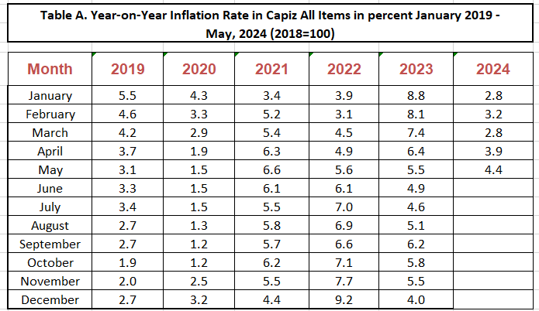
Source: Retail Price Survey of Commodities for the Generation of Consumer Price Index, Philippine Statistics Authority
CONCEPTS AND DEFINITIONS
Figure 2

CONSUMER PRICE INDEX (CPI)

- A measure of the change in the average price level of goods and services that most people buy for their day-to-day consumption.

- It measures the composite change in the consumer prices of various commodities over time.

COMPONENTS OF THE CPI

- Market Basket - A sample of the variety of goods and services commonly consumed by an average Filipino household to represenrt the price behavior of all goods and services bought by consumers.

- Weight - Value attached to a commodity or group of commodities depending on the magnitude of its contribution to the index.

- Base Period - A reference year at which the index is equal to 100. The present base period/year used is 2006.

INFLATION RATE

- It is the annual rate of the change or the year-on-year changes in the average retail prices.

PURCHASING POWER OF THE PESO (PPP)

- It shows how much the peso in the base period is worth in the current period. It is computed as the reciprocal of the CPI for the period in review multiplied by 100.

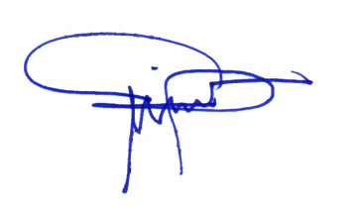
ROSIEBELLE A. BELUSO
OIC - CSS-Provincial Statistics Officer

For more inquiries regarding this special release please contact:

The Statistical Staff
Philippine Statistics Authority
Capiz Provincial Statistical Office
Ground Floor Catalan Building
Magallanes Street,, Roxas City
Tel. Nos. (036) 6210-127 & 6215-963
email: psacapiz@gmail.com

Figure 2

